APTITUDE
(AcquirING THE POWER of Teaching Initiative Through an Urge of Dramatization in English)
3 day workshop for TTI students of Palakkad district in English Theatre – 2010 July 16,17,18 DIET Palakkad

English communication has a prominent role in the learning of English language. An English atmosphere should be created and child accommodates the basic language skills and vocabulary of life. Most of our teacher trainees and teachers face an unknown inhibition to render the language in front of a group. This made their interactions in English became artificial. Children need to hear the spontaneous and natural flow of English.
It is important to erase the inhibitions, develop creative and constructive thinking, develop imagination, accommodation, expressions and perform in English without any imposition. Theatre is the proper way to create self confidence and self actualization.
During these three day workshop it is expected to address most of our problems in English.

Objectives:
To eradicate all inhibitions including speaking in English.
To develop theatre skills.
To experience creative thought and constructive thought.
To express intuitions and the daily life in English.

To experience the proper usage of theatrical elements in English class room.
To know the geometry of theatre and chemistry of performance.
To develop trainer capacity to conduct same workshop in ones own TTI

FIRST DAY OF THE WORKSHOP INAUGURATION
16-7-2010 Friday
programme
11am
WELCOME;SARANYA
MODERATOR;DIVYA
INAUGURATION; Mr. A. RAJENDRAN(DIET LECTURE)
FELICITATION; Mr.RAMACHANDREN(S N TTI KOTTAPPURAM)
Mr.GIRIJAKUMARANPILLAI(DIET LECTURE)
Mrs.MERCY SAMUAL.(DIET LECTURE)
Ms.NAJULA.P.K.(STUDENT TEACHER)
VOTE OF THANKS;SHAHANA SALEEM.

FROM INAUGURAL SPEECH;
Now a day we show reluctance to use English in essential occasions even though we are competent in vocabulary and grammar. The main reason of this situation is the lack of confidence. It can be improved by combining acquisition of language, creativity and theatre. So the emphasis of the theatre workshop is to improve the proficiency of communicative skill in English language. English is the key hole to the modern technology.

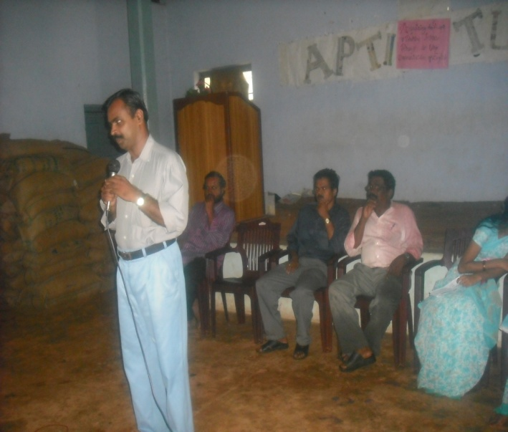
SESSION1
THEATRE GAME1
Leader ( Vasudhevan sir): “All of you please listen my words. Can you see my beautiful hands? I think, my hand is the most beautiful in the world. My fingers also. When ever I am drawing a circle in the air with my beautiful finger, all of you want to make a clap at a time.” (The process got speedy)
THEATRE GAME 2
Leader: I request each and every one of you to gather in a round manner, in which the person who I suggested should walk with his own style.
THEATRE GAME 3
Leader: Please sit in round group and I will give you an imaginary gift (jackfruit, cat, needle etc...) which you have to exchange to your neighbour with the expression.

THEATRE GAME 4
Leader: Suppose you are walking alone in a see shore with some problems in your minds. You are in deep a deep thought. At that moment you met one of your old friends called whale friend and starting to share your problems and details. After that you are continuing your walk along a stream, where you met another friend called cat friend and there also you are sharing your details. Then you are in a slippy rock. There you found snake friend and also sharing the details.
THEATRE GAME 5
Leader: Any one of you please get stand up and introduce your cat friend/whale friend/snake friend in a chain manner.
Teacher as an actor
SESSION 2 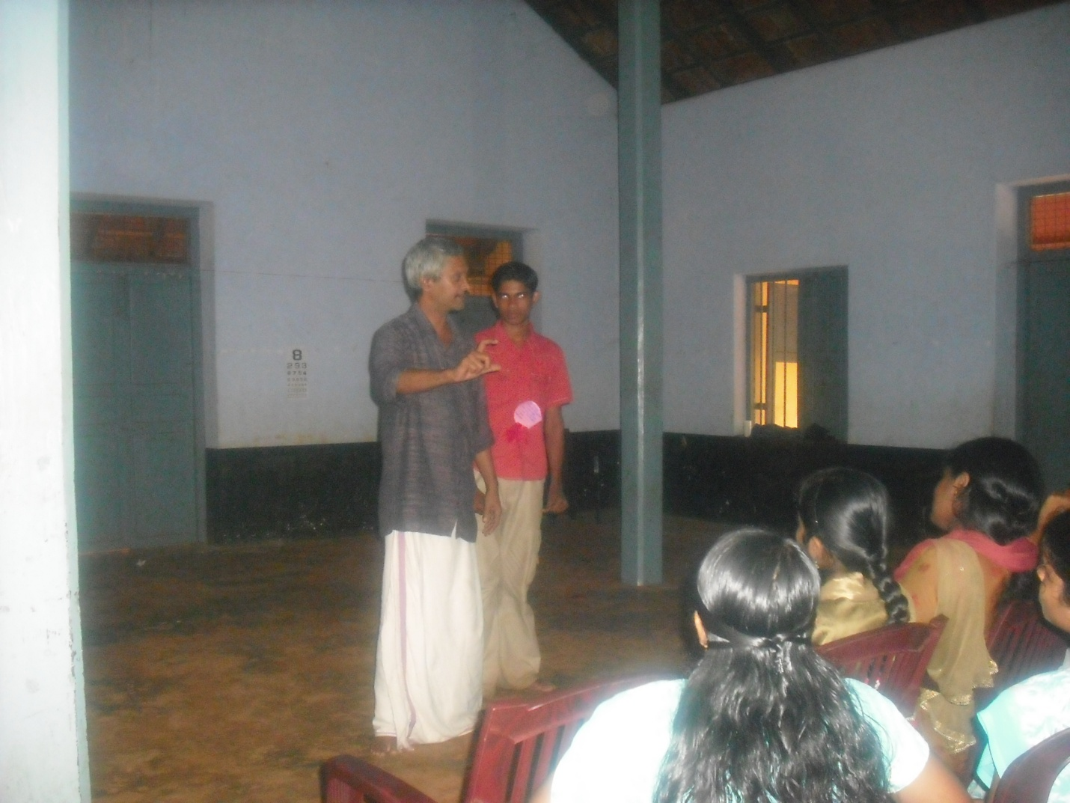
Teacher as an actor

ACTIVITY 1
Leader ( Narippatta Raju ): Request you to turn in nine groups, which contain four members in each and the group members can select any theme that can be applicable in one to seventh standared and are requested to perform it.
INSTRUCTONS
After the presentation leader pointed out some faults.
1. Teacher should enter the class room with confidence.
2. Teacher has to attain the ability of observation skill.
3. Teacher must provoke the students.
GEOMETRY OF STAGE
UP CENTRE
UP RIGHT UP LEFT

CENTRE RIGHT CENTRE LEFT
DOWN LEFT
0 0
DOWN RIGHT DOWN CENTRE MIDDLE CENTER 0

SESSION 3
THEATRE GAME 6
Leader ( Vasudhevan sir ): Students, I am going to dividing you as nineteen pairs and you are requested to stand pair by pair in the form of a tunnel which has the chain structure. At that time I will pass through that. Same way the last pair formed in the class room have to pass through that and make that pair in front of the chained tunnel. Same way each pair of also continue as like that.

THEATRE GAME 7 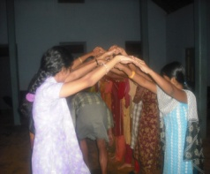
Leader: Please form a new paired group which you were formed before. In that, one member of you have to express the thing that what ever I am going to say. ( The thing can be an experience, any theme etc...)

ACTIVITY 2
Leader ( Narippatta Raju ): Now we are going to form a new paired group. First of all you have to walk in a random manner and I will tell you to stop. At that time you are stand there and start to count one, two- one, two like that. Then all ‘one’ fix their own place and ‘two’ want to walk their right side to the third number. Thus you will form a new group. Then our game will start. One of the members of your group have to say any theme to other person for acting and vise- versa
REVIEW
In the time of review the participants shared their experiences.
FROM THE REVIEW:
1. Shahana said about her improvement of performance in English.
2. Arathi told about the development of confident level.
3. Radhika told that she got a clear idea about how to control the students in a class.
4. Nithya said that she got an idea about how can be present a story in the class. (Including the sound modulation)
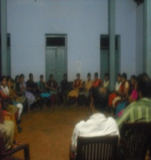
IT’S THE TIME FOR REVIEW

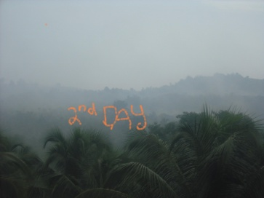

SESSI0N 1
ACTIVITY
AEROBICS
The second day start with aerobics. Aerobics is a rhythmic physical exercise ,it related to intended to improve the intake of oxygen and its movement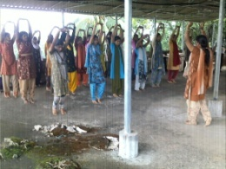

SESSION 2
THEATRE GAME 1
Leader ( Vasudhevan sir ): Sit in round and start to count 1, 2, 3 like that. But after the three members, the next member have to make a typical sound like ‘ttoo’. If one failed to do this, I will tell you who wants to give the punishment to that person and he should be responsible to do that.
ACTIVITY 4
Leader: one of the members of your group say a word. The next one continues with this and make a sentence which should be a meaningful one.
Leader: Arrange chairs in a circle and assign each participant a fruit’s name. I call out one of the fruits like ‘apple’. At that time all of you assigned to be apple must be find a new seat. Repeat with a different fruit. Also can be called fruit salad, which means every single players must find a new seat
Visit of principal in the workshop
The diet principal Mr. C. Babu visit the theatre workshop at 12.30.PM.Some time he interact with the members.
FROM THE SPEECH OF PRINCIPAL

Theatre can be use as a pedagogic strategy in the class room.
Selection of vocabulary in small classes is very important.
We should be able to understand the level of students.
ACTIVITY 5
Telling the Group a story
One person tells the rest of the group a story, or
describes an event or gives them a talk on a set subject.
The others interrupt him by asking totally unrelated
questions. The speaker must answer the questions and
then continue with the story or talk without hesitation,
and from exactly the point where he left off.
ACTIVITY 6
PERFORMENCE OF THE STORY
LEADER: Now you can perform the story. After the performance we have discuss about it.
FROM THE PERFORMANCE
1. Please listen the stage arrangement.
2. Design the location in your mind.
3. Your movement should be according to the location.

Leader: you can take any objects and do any an action using the same but
when the leader calls ‘I-Love you’, they have to find out that
partner and hand over fhe property they have to continue in that emotion till the leader of acalls out for new pair with another emotion but with out using dialogue.

REVIEW

1. Radha said that we realize the important factors of a drama which we are going to performing.
2. Ranjith said that ,he got an whole idea about the performance.

